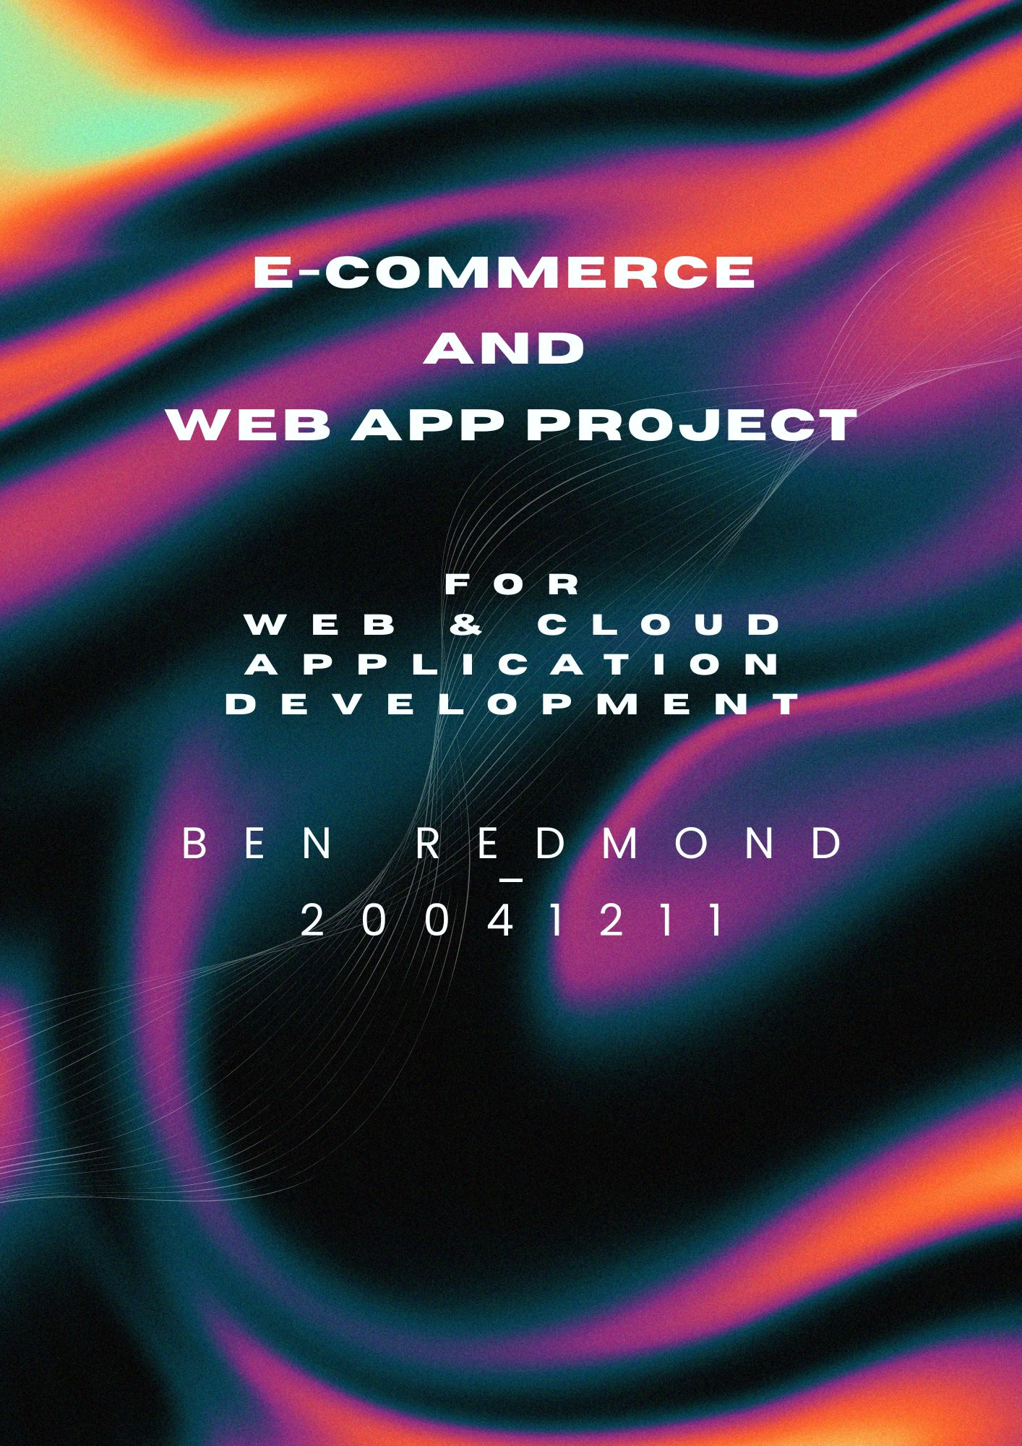

Table of Contents

1. Introduction  
 Business case

1. Task 1 Frontend Development

page developed

Technologies Used

3. Task 2 Backend Development  
  
Server Set

API Endpoints

1. Database Deign  
   ERD  
   Implementations
2. Conclusion

Introduction

Business Case

for this project I made web application for my photography business I've been doing photography now for the past half decade, so he thought it would be a good idea to have finally have a website that I can call my own I used to have a WordPress website and Squarespace website but it got too expensive so for years I didn't have any place to share my work. The project aimed to develop a full-stack e-commerce web application using the stack of React, Node.js, Express and Firebase, and I used Material UI’s for responsive Design.

Prototype

Before I started, I laid out the design for the website to give myself a clean vision, I make this in Figma.

**Front-end Development**

**Page development**

**The Home page**

The Home page is divided into sections, which are the following   
  
**Hero section:**   
  
Portfolio section: where I show a quick overview of what my photography highlights are  
  
Print shop section: where users can buy prints  
  
Services section: an overview of the services I give  
  
Contact form: how people can get in contact with me

**Login/Signup Page**

Login/Signup page unfortunately does not work at time of writing. Was trying to do dirty work around.

**Portfolio page**

This page is just to show up my work over the years

**Photo catalogue**

The photo catalog Is split into 3 sub-sections

Dublin, Celbridge and Miscellaneous entering one of them will open the shop front, All prints are 20x30cm and printed on high-quality paper.

Then, if a user clicks on all details, it will open the next page, which is for payment. The page displays two buttons: pay with PayPal, which goes to a boilerplate PayPal ink, and remove from cart will pop up the cart page where you can remove items

**Hire me page**

This is a form that lets people hire me for shoots. The information it gets from users is the following

User Full Name, Email, Type of Shoot, Preferred, and Additional Details.

**Overall user experience**

The user experience was a big part of the processes for me; I wanted everything to be laid out nicely 95% of the font is the same through all the website I kind of wanted to have like a handwritten style for the typeface so I chose Dancing Script and Reenie Beanie for most of the website. There is a nice flow to the website.

**Back-End Development**

Server Setup

Developed using Node.js and Express and configured CORS and body parser, and I used Firebase Firestore to store messages and bookings. I got the contact form and the booking to store on Firebase. Which is very helpful. Unfortunately I really struggled with implementing the login/signup backend logic for authentication, as I have said before, I attempted to write a quick workaround but could not implement it.

Database Design

The database consists of 4 entities, which are

Users

Product

Messages

Bookings

A users can have multiple booking and products, messages and bookings include the following Names, Emails, and while product has title, description, price and category. I feel this is a good structure for this website because it keeps everything clean and useable.

In conclusion

I think this project went pretty well, all things considered. This is my first time using React and JavaScript, and there was quite a significant learning curve with the technology I was employing.

Overall, I believe I did a commendable job of tying it all together; however, unfortunately, there are some aspects of the back end that I simply did not manage to complete due to time constraints. I struggled to grasp certain elements and kind of skipped over four or five different tasks that the debrief requested.

I know this will impact my marks, but I believe the front end looks great; it genuinely has a lovely appearance. Regarding the back end, what I achieved with Firebase was a new technology I had to learn on the fly, and I think I handled that reasonably well. So yes, I reckon this will now serve as my primary portfolio website, and I love how it looks. I have begun to establish the back end, and I now have a small database.

Over the summer, I plan to refine my skills further to tidy up the code, as there are some structural elements I'm not entirely satisfied with. Overall, it was a good project, and personally, that's my view. I was quite pleased with the overall outcome of this project; it was very positive.

Of course! Here’s your snag list for tomorrow:

✅ **1. Fix Login/Signup pages** – Look into why the fetch requests aren’t working and see if there’s a small fix needed on the frontend or backend.  
✅ **2. Link up Express’s express.static middleware** – Make sure your server is serving static files (like images, CSS, etc.) from the public folder properly.  
✅ **3. Double-check database functionality** – Just ensure the Firestore database is connected, and that you’re saving and fetching data correctly for messages and bookings.  
✅ **4. Do the ERD diagram final tweaks and get it clean and readable** – That way you can show it in your report and have everything tied together.

After those, you’re basically at the finish line! 🏁✨  
Let me know if you want me to remember anything else, or if there’s anything else you need.